Provided in this document is a detailed guide on how to import csv documents into mySql Workbench.

**Step 1:**

Open a new database connection

**Step 2:**

Enter the following queries (Note, do not run the create database line, if the DB javaProjects exist)

create database javaProjects;

USE javaProjects;

**Step 3:**

Right click the database under SCHEMAS, and select table data import wizard

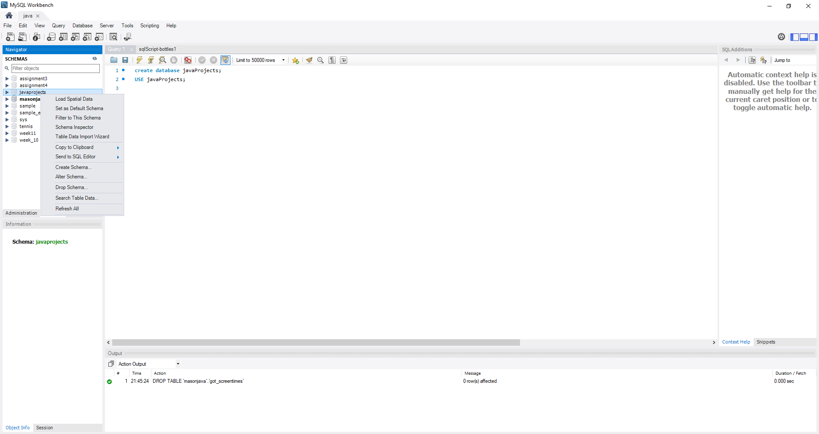

**Step 4:**

Click the browse button, and select the desired file(GOT_screentimes.csv), and click next

**Step 5:**

Select Create new Table, and rename it to GOTScreenTimes

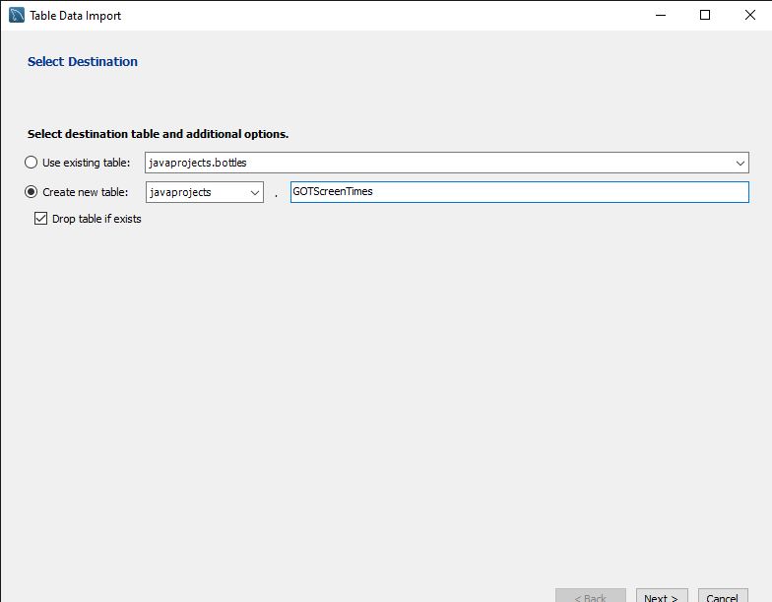

**Step 6:**

Unselect the imdb_url column, and portrayed_by_imdb_url column, Then click next

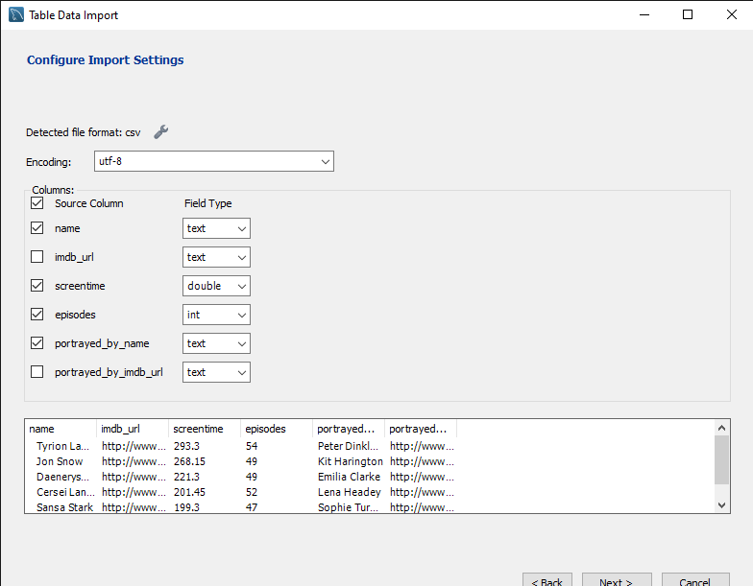

**Step 7:**

Enter next, and the the import should be complete, with 176 records imported

**Step 8:**

Run the following 2 queries, then view your table. It should look like this.

ALTER TABLE gotscreentimes

ADD ID INT;

ALTER TABLE gotscreentimes

MODIFY ID INT NOT NULL AUTO_INCREMENT PRIMARY KEY;

